Interactive Analysis Dashboard For Global Income Distribution
Project Documantation (Milestone 2)
Prepared By : Onkar Vyawahare
Project Domain : Data visualization
1.Project Overview
Interactive Analytics Dashboard for Global Income Distribution project aims to develop an interactive Power BI dashboard that visualizes income inequality data across various countries and regions. This project involves collecting, preprocessing, and structuring global income distribution and economic data to enable effective visualization. The dashboard will provide users with insights into income disparities over time, country-wise comparisons, and patterns of inequality globally.
2. Milestone Overview
Weeks 3-4: Data Structuring, Transformation, and Power BI Dashboard Development:
●Structure data into a standardized format for visualization.
●Perform data transformations like normalization, aggregation, and calculation of inequality metrics.
●Design the layout of the Power BI dashboard with global comparisons, region-wise trends, and income distribution visualizations.
●Develop visualizations that highlight income gaps, country-level inequality, and changes over time.
●Add filters, slicers, and interactive elements to allow customized exploration.
●Ensure the dashboard is visually appealing and user-friendly.
Week 3 : Data Structuring, Transformation
1.Data Structuring
Data structuring is the process of organizing raw dataset into a standardized and analysis-ready format suitable for visualization in Power BI.
1.1 What Was Done:
- Cleaned country and region fields
- Ensured consistent numeric formatting (GDP, Gini, Unemployment)
- Standardized percentage columns
- Structured data into country-year format for time analysis
1.2 Purpose:
To make data suitable for:
- Cross-country comparison
- Regional aggregation
- Trend analysis over time
Role in Project:
It ensures accurate calculations and prevents aggregation errors (like SUM of Gini).
2. Data Transformations Performed
Data Transformation is the process of cleaning, structuring, modifying, and preparing raw data into a meaningful and standardized format suitable for analysis and visualization.
Normalization
- GDP per capita standardized
- Inequality metrics scaled (0–100 range)
- Severity scores created for better interpretation
Aggregation
- Regional GDP totals calculated
- Country counts computed
- Regional averages calculated
Derived Metrics (Inequality Indicators)
- Gini YoY Change
- Income Polarization Index
- Middle Class Income Share
- Inequality Severity Score
These transformations convert raw numbers into meaningful insights.
3. Calculated Columns
A Calculated Column is a column created using DAX (Data Analysis Expressions) that performs row-by-row calculations within a table.
3.1 Calculated Columns Used
Country_Continent
Identifies the continent to which each country belongs for regional analysis.
GDP_Per_Capita_Category
Classifies countries into income groups based on GDP per capita levels.
Gini_Inequality_Level
Categorizes countries into low, moderate, or high inequality based on Gini Index values.
Income_Share_Gap
Calculates the income difference between the highest 20% and lowest 20% groups.
Middle_Class_Income_Share
Represents the combined income share of the middle 40% population.
Unemployment_Level
Classifies countries into low, medium, or high unemployment categories.
Year_Group
Groups years into broader time periods for trend-based analysis.
4. Calculated Measures
A Measure is a dynamic calculation created using DAX that computes aggregated values based on the current filter context in a report. Measures are not stored as columns; they are calculated when visuals are generated.
4.1 Calculated Measures Used
Country_Strength_Score
Represents a composite index measuring a country’s overall economic and social performance.
GDP_YoY_Change %
Shows the year-over-year percentage change in GDP per capita to measure economic growth trends.
Gini_Inequality_Severity_Score
Provides a scaled score indicating the intensity of income inequality within a country.
Gini_YoY_Change
Measures the annual change in the Gini Index to track shifts in income inequality over time.
Income_Polarization_Index
Quantifies the income distribution gap between population segments to assess economic polarization.
Region_GDP_%_Contribution
Displays each region’s percentage contribution to total global GDP.
Region_Total_GDP
Calculates the aggregated GDP of all countries within a specific region.
Total_Countries
Counts the total number of distinct countries included in the dataset.
Unemployment_Region_Average
Computes the average unemployment rate across countries within a region.
Unemployment_Rank
Ranks countries based on unemployment rate for comparative analysis.
Unemployment_YoY_Change
Shows the year-over-year change in unemployment rate to monitor labor market trends.
Challenges Faced During Transformation
- Incorrect aggregation (SUM instead of AVERAGE for Gini)
- Handling percentage vs numeric formatting
- Creating dynamic regional calculations
- Managing time-based calculations (YoY)
- Avoiding double counting in regional totals
Overall Purpose of Transformations
- Convert raw economic data into analytical indicators
- Enable country, regional, and global comparison
- Support trend analysis over time
- Improve visualization accuracy
- Provide deeper insight into inequality patterns
Screenshot

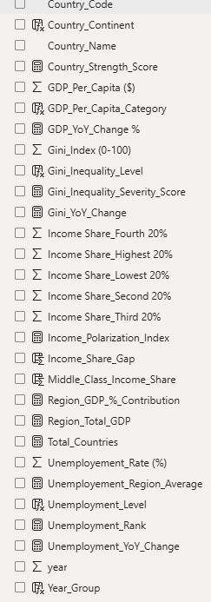

Week 4 : Power BI Dashboard Development
5. Power BI Dashboard Development
5.1 Dashboard Objective
The dashboard is designed to provide an interactive analytical view of global income distribution, economic growth, and inequality patterns across countries and regions over time.
It enables:
- Global comparison
- Regional trend analysis
- Income distribution visualization
- Dynamic filtering by year, continent, and country
5.2 Dashboard Section-wise Analysis
A. Slicers Section
Components:
- Year
- Country Continent
- Country Name
- Year Group
Purpose:
dynamic filtering of data across all visuals for customized analysis.
B. KPI Cards Section
Indicators Displayed:
- Total Countries
- Total Gini Index
- Total GDP Per Capita
- Total Unemployment Rate
- Country Strength Score
- Gini Inequality Severity Score
Purpose:
Provides a quick executive summary of global economic and inequality indicators.
C. Global Overview Section
Visuals Included:
- Top 10 Countries by Gini Index (Bar Chart)
- Income Inequality Distribution Map
- Global Income Distribution Structure (Donut Chart)
Purpose:
Provides country-level and global income distribution insights.
E. Regional Comparison Section
Visuals Included:
- Regional GDP Per Capita Comparison
- Regional Inequality Levels (Gini Index)
- Regional Unemployment Rate Comparison
Purpose:
Compares economic performance and inequality across continents.
F. Trend Analysis Section
Visuals Included:
- GDP Per Capita Growth Trend
- Income Inequality Change Trend (YoY)
- Unemployment Rate Change Trend (YoY)
Purpose:
Tracks changes over time in economic growth, inequality, and unemployment.
G.Two Indicators Comparison Section
Visual:
Economic Growth vs Income Inequality (Scatter Plot with Play Axis)
Purpose:
Analyzes the relationship between GDP per capita and Gini Index.

5.3 Layout Architecture
The dashboard follows a top-to-bottom analytical flow:
- Filters
- KPI Summary
- Global Overview
- Regional Comparison
- Trend Analysis
- Indicator Relationship
5.4 Visual Design Decisions
- Consistent color theme for professional appearance
- Rounded containers for modern UI
- Balanced spacing to avoid clutter
- Horizontal bar charts for better label readability
- Donut chart for income share representation
- Scatter plot for relationship analysis
5.5 Analytical Capabilities
The dashboard enables:
- Country-level inequality analysis
- Regional economic comparison
- Income distribution structure analysis
- Trend-based economic evaluation
- Correlation analysis between GDP and inequality
5.6 User Experience (UX)
- Clear visual hierarchy
- Logical grouping of sections
- Detailed analytics below
- Easy navigation with slicers
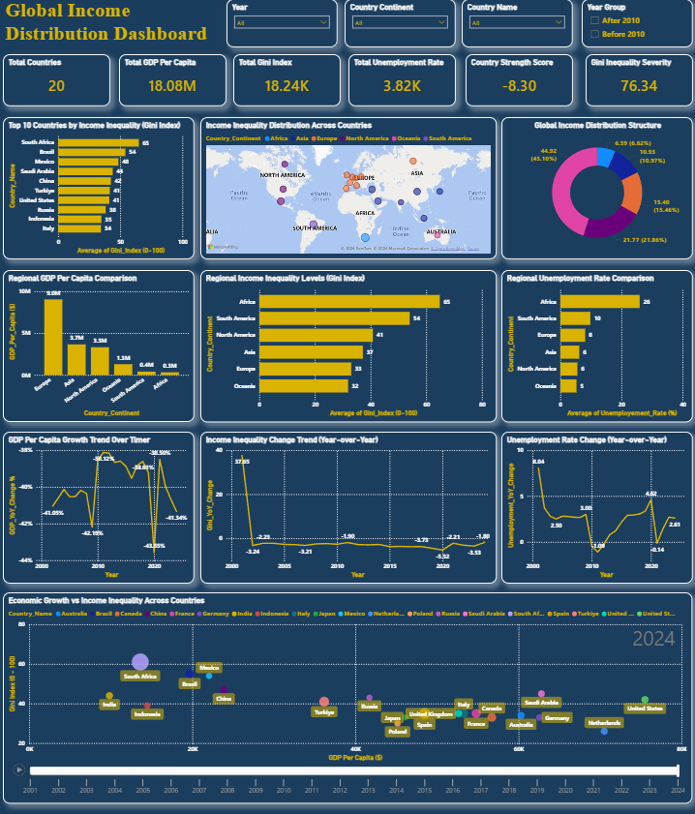

Conclusion
The data was transformed into analytical indicators and visualized through an interactive Power BI dashboard, enabling dynamic analysis of global income distribution, inequality, and economic trends.

